|  |  |  |  |  |
| --- | --- | --- | --- | --- |
|  | **ATPHY 2018**   |  |  | | --- | --- | | **Electromagnetism Investigation** | **3.0%** |   **Part (2) Quiz: Solutions** | |
| Student name: | |  |



Questions:

1. State what the betatron is mainly used for. [3]

It accelerates electrons to high speeds. [1]

It is used in producing x rays and [1]

for medical purposes such as cancer therapy. [1]

2. What is the value of the speed mentioned as *v* = 0.999987*c* where *c* is the speed of light? Give your answer to 5 significant figures. [2]

v = 0.99987 x 3 x 108 [1]

= 2.9996 x 108 m/s [1]

3. Show that 1 Volt = 1 Weber / second. [3]

1 Wb / s = $Φ$/t [1]

By Faraday’s Law, induced emf $ε=-N\frac{∆Φ}{∆t}$ [1]

For a change of 1 Wb / s, an emf of 1 Volt is induced. [1]

4. Explain why an electron-volt can be considered to be a unit of energy. [2]

1eV = 1 x charge of an electron x voltage applied to electron. [1]

As W = qV, 1 eV is actually a measure of work done on the electron or change in energy. [1]

5. Can an induced current ever establish a magnetic field B that is in the same direction as the magnetic field inducing the current? Justify your answer. [3]

No, it cannot. [1]

It would violate the law of conservation of energy. [1]

If that were true, the magnetic field would add up to get stronger. Energy is being created and not being converted to other forms. [1]

6. Suggest a suitable material for the magnetic core of the betatron. Justify your answer. [2]

It could be made of a soft iron core. [1]

The iron core concentrates the magnetic field. OR

It is easily magnetized and demagnetize and is responsive to the alternating current. [1]

7. In the betatron, the magnetic core is made of laminated sheets rather than of solid material. Explain why this is so. [3]

Laminated sheets are designed to reduce the eddy currents [1]

that result from Lenz’s law where a current is induced that opposes the change in magnetic flux [1]

If solid material was used, the heat loss due to the eddy currents would be very large. [1]

8a) Explain how the magnetic field guides the electrons in a circular path. [2]

The magnetic field acts on the moving electrons and produces the Lorentz electromagnetic force. [1]

This force acts perpendicular to the motion of the electrons. [1]

This results in giving the electrons a circular path.

b) Explain how the changing magnetic field produces an induced electric field in the electron chamber. [2]

By Faraday’s Law, the induced emf is proportional to the rate of change of magnetic flux linked. [1]

The changing magnetic flux acts on the moving electron and produces an induced emf in the chamber. [1]

9. You want to increase the radius of the circular path by imposing an additional magnetic flux $∆Φ$. Should the lines of *B* associated with this increase be in the same direction as the lines shown in the figure or in the opposite direction?

Explain your answer. [3]

They should be in the same direction to have added flux. [1]

$Φ$ = B.A. Flux is given by the product of B and the area enclosed by the magnetic field lines. [1]

The sum of the two B fields in the same direction gives greater B and hence an additional flux B.A. [1]

10. State the direction of the force acting on the electron on the right hand side of the betatron. [1]

Toward centre of orbit [1]

Explain how you arrived at your answer. [2]

Using the right hand palm rule, the fingers point in the direction of B, the thumb points out of the page (in direction opposite to electron flow), [1]

the palm gives the direction of the electromagnetic force. [1]

**11.** In a 100-MeV betatron, the orbit radius *R* is 84 cm. Assume that the orbit is circular. The magnetic field in the region enclosed by the orbit rises periodically (60 times per second) from zero to a maximum value $B_{max}=0.8\text{T}$ in an accelerating interval of one-fourth of a period, or 4.2 ms.

(a) What is the maximum magnetic flux, $Φ_{max}$, attained during the accelerating interval? [2]

$Φ_{max}=\left(B_{max}\right)\left(πR^{2}\right)$ [1]

$=\left(0.80T\right)\left(π\right){\left(0.84m\right)}^{2}=1.77 Wb$ [1]

(b) Using the answer to (a), determine the rate of change of flux (induced emf) during the time interval of acceleration. [2]

$\frac{∆Φ}{∆t}=\frac{1.77 \text{Wb}}{4.2×{10}^{-3}}$ [1]

$=421 \text{Wb/s or }$ V [1]

(c) Given that 1 eV (electron volt) is the energy gained by an electron moving across a potential difference of 1V, show that the number of revolutions required for an electron to reach its final energy of 100 MeV is approximately 238,000 revolutions. [2]

Number of revolutions = 100 x 106 / 421 [1]

= about 238,000 revolutions [1]

(d) Find the total distance travelled by an electron along its circular path before reaching its full energy of 100 MeV. [2]

Total distance = 238,000 x 2 x π x 0.84 [1]

= 1250 km [1]

(e) Calculate the average speed of the electron as it travels the total distance needed to reach 100 MeV during the acceleration time interval of 4.2 ms. [2]

Average speed = distance / time = 1250 x 103 / 4.2 x 10-3 [1]

= [1]

12. The varying magnetic field in the betatron can be represented by the graph below:

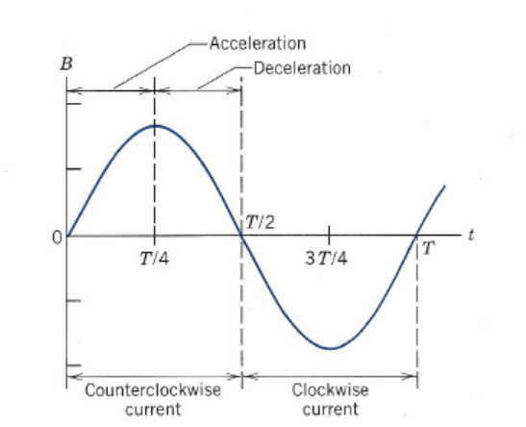

On the axis below, sketch the shape of a corresponding graph of induced emf versus time as the B field varies. [3]

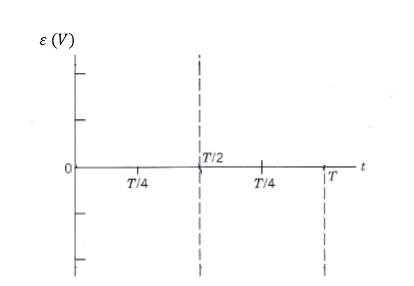

Periodic sinusoidal shape [1]

Maximums at right times [1]

Minimums at right times [1]

13. Once accelerated, the electrons are directed out of the doughnut chamber, or inwards, towards a metal target to produce x-rays.

X-rays are a form of electromagnetic radiation. They have a wavelength ranging from 0.01 to 10 nm.

(a) What are the highest and lowest frequencies of x-rays? [3]

$v=fλ$ [1]

$v=3.00×{10}^{8}\text{m/s}$

When wavelength = 0.01 nm; = 3.0 x 108/0.01 x 10-9 = 3.0 x 1019 Hz [1]

When wavelength = 10 nm; = 3.0 x 108/10 x 10-9 = 3.0 x 1016 Hz [1]

14. The betatron can be thought of as a transformer. Transformers have a primary and secondary coil. The magnetic field is changed by passing alternating current to the primary coil. A current is induced in the secondary coil by Faraday’s Law. [2]

(a) State which part of the betatron behaves like the primary coil of a transformer.

The primary coil is the coils C. [1]

(b) State which part of the betatron behaves like the secondary coil of a transformer.

The secondary coil is the ring of electrons in the tube. [1]

15. Referring to the values given in Question 11, suggest some strengths of the design of a betatron as a particle accelerator. [2]

It can be of a small size. The radius in our example is 84 cm. [1]

The value of the B field applied of 0.8T is not too large compared to other particle accelerators. [1]

16. What are some ways that you can increase the energy of radiation emitted by the betatron? [2]

We can increase the strength of the alternating current. [1]

We can increase the frequency of injection of electrons. [1]